Cybersecurity Analyst Internship
Task Report

[samfelix15@gmail.com]
Task No: [Task 4 - Cybersecurity Fundamentals]

Copyright © 2024 EncryptEdge Labs. All rights reserved
Credit: Offensive Security

Table of Contents
1.0 EncryptEdge Labs Internship Task Report 3
1.1 Introduction 3
1.2 Objective 3
1.3 Requirements 4

2.0 High-Level Summary 16
2.1 Recommendations 16
2.2 Risk exposure over time 17

3.0 Report - Methodologies 17
3.1 Information Gathering 18

4.0 Additional Item: 19
4.1 Summary Conclusion
4.2 Screenshots X
1.0 EncryptEdge Labs Internship Task Report
1.1 Introduction
In today's digital age, cybersecurity has become a critical concern for individuals, businesses, and governments worldwide. As technology advances and the internet becomes increasingly intertwined with our daily lives, the risk of cyber threats and attacks has grown exponentially. To mitigate these risks, it is essential to understand the fundamentals of cybersecurity.
What is Cybersecurity?
Cybersecurity refers to the practices, technologies, and processes designed to protect digital information, computer systems, and networks from unauthorized access, use, disclosure, disruption, modification, or destruction. This includes protection against malware, viruses, Trojan horses, spyware, adware, ransomware, and other types of cyber threats.
Key Concepts in Cybersecurity:
1. Confidentiality: Ensuring that sensitive information is only accessible to authorized individuals or systems.
2 Integrity : Ensuring that data is accurate, complete, and not modified without authorization.
3 Availability: Ensuring that data and systems are accessible and usable when needed.
4.Authentication Verifying the identity of users, devices, or systems before granting access.
5 Authorization : Granting or denying access to resources based on user identity, role, or permissions. To help build a strong understanding of essential cybersecurity terms which will support you in your role as a cybersecurity analyst
To help gain an understanding of the different types of cyber treat that organizations encounter and learn how each operates and impact security
To understand the responsibilities of a cybersecurity analyst and the role they play in cybersecurity framework.

In this chapter, we will explore the key vital cybersecurity terminologies and the role each of them play in the world of cybersecurity.

1.3 Requirements
The purpose of this report is to provide a comprehensive introduction to Cybersecurity and its fundamental must know. Concentrating on security best practices, threat intelligence and incidence response.
Key Objective
1. Define the basic of cyber security
2. Identify and explain common cybersecurity roles, terms, analysis and response to emerging threats
3. Provide tips and best practices for getting started with cybersecurity
Deliverables:
Submit a glossary of cybersecurity terms and a brief explanation for each of them
Include a brief summary of the common cyber threats describing their characteristics, mitigation and impact on cyber threats
Outlying the responsibilities of a cybersecurity analyst and the key task they perform to protect organizational systems
Limitations:
This report will focus on basic of understanding cybersecurity and its related areas and will not cover advanced topics of any kind
Tools Used: Understanding cybersecurity bssics - medium article, Cybersecurity basic concepts and basic principles

SECTION A
In this section we explore the various cybersecurity terms and the role they play in a cyber-defence environments.

ENCRYPTION :
The process of converting plaintext data into unreadable ciphertext to protect it from unauthorized access. Encryption ensures confidentiality and integrity of data.
Encryption comes in different types. Most widely used type of encryption may include
Symmetric Encryption
- Uses the same key for encryption and decryption.
- Examples: AES (Advanced Encryption Standard), DES (Data Encryption Standard), Blowfish.
Asymmetric Encryption
- Uses a pair of keys: a public key for encryption and a private key for decryption.
- Examples: RSA (Rivest-Shamir-Adleman), Elliptic Curve Cryptography (ECC).
Hashing
- A one-way process that transforms data into a fixed-length string of characters.
- Examples: SHA-256 (Secure Hash Algorithm 256), MD5 (Message-Digest Algorithm 5).
Block Cipher
- Encrypts data in fixed-length blocks.
- Examples: AES, DES.
Stream Cipher
Encrypts data in a continuous stream.
Examples: RC4 (Rivest Cipher 4), FISH (Fast and Secure Hash).
End-to-End Encryption (E2EE)
Encrypts data on the sender's device and decrypts it on the recipient's device.
Examples: WhatsApp, Signal.
Homomorphic Encryption
Enables computations to be performed on encrypted data without decrypting it first.
Examples: Brakerski-Gentry-Vaikuntanathan (BGV) scheme.
Quantum Encryption
Uses quantum mechanics to encrypt data.
Examples: Quantum Key Distribution (QKD).
These types of encryption serve different purposes and offer varying levels of security, making them suitable for different applications and use cases.
An example of an encryption application is an online banking systems use encryption to protect sensitive information, such as account numbers and passwords, when transmitted over the internet.
Even though we are prone to so many types of encryption systems ,there are widely used common protocols associated with encryption. They may include
SSL/TLS (Secure Sockets Layer/Transport Layer Security)
AES (Advanced Encryption Standard)
RSA (Rivest-Shamir-Adleman)
PGP (Pretty Good Privacy)

FIREWALL
A network security system that monitors and controls incoming and outgoing network traffic based on predetermined security rules. Firewalls act as a barrier between trusted and untrusted networks.
Examples of devices that serves as firewalls includes our great routers (default gateways). Others may include
Dedicated firewall aplliances. Eg Cisco ASA,Junipa SRX
Servers with firewall softwares
Next Generation Firewalls. Eg Fortinet etc
Unified Threat Management (UTM) eg Sonic Wall,Cyberoam
Virtual Firewalls eg VMware vSheild, AWS Security Groups
An example if a firewall application is a company's network firewall blocks incoming traffic from unknown sources, preventing potential hacking attempts.
Here are few protocols associated with task carried by firewalls
TCP/IP (Transmission Control Protocol/Internet Protocol)
UDP (User Datagram Protocol)- Unencrypted
ICMP (Internet Control Message Protocol)
Firewall rules and configurations (e.g., iptables, pf,ACLs)

PENETRATION TESTING
Penetration Testing (Pen Testing): A simulated cyberattack against a computer system, network, or web application to assess its security vulnerabilities. Pen testing helps identify weaknesses before malicious attackers can exploit them.
There are several vital tools used for penetration testing. But know someway somehow every tool serves a dominant purpose all depending on the kind of pen testing approach. Some examples of penetrating testing may include
Metasploit: Used in exploitation frameworks (vulnerability exploitation)
Hydra: Network Logon Cracker (Password cracking and brute forcing)
SQL Map- SQL Injection Tool (Web Application security testing)
Wireshark -Network Protocol Analyzer (Wireless Network Security Testing)
An example of a penetration testing application is a cybersecurity consultant performs a penetration test on a company's web application, identifying vulnerabilities that could be exploited by attackers.
Protocols and frameworks:
NIST 800-115 (Technical Guide to Information Security Testing and Assessment)
OWASP (Open Web Application Security Project) testing framework
PTES (Penetration Testing Execution Standard)
INCIDENCE RESPONSE:
A structured approach to managing and responding to cybersecurity incidents, such as data breaches or ransomware attacks. IR aims to minimize damage, reduce recovery time, and restore normal operations. Some examples and nature of incidence response may include the following

Data Breach Response
Responding to unauthorized access or theft of sensitive data.
Examples: Equifax data breach, Yahoo data breach.
Ransomware Response
Responding to malware attacks that encrypt data and demand payment.
Examples: WannaCry, NotPetya.
Denial of Service (DoS) Response
Responding to attacks that flood a system or network with traffic.
Examples: Distributed Denial of Service (DDoS) attacks.
Phishing Response
Responding to social engineering attacks that trick users into divulging sensitive information.
Examples: Email phishing scams, spear phishing attacks.
Malware Response
Responding to malicious software that compromises system security.
Examples: Virus outbreaks, Trojan horse attacks.
Network Intrusion Response
Responding to unauthorized access or malicious activity within a network.
Examples: Insider threats, advanced persistent threats (APTs).
Physical Security Incident Response
Responding to physical breaches or unauthorized access to facilities.
Examples: Unauthorized entry, theft of equipment.
Cloud Security Incident Response
Responding to security incidents in cloud computing environments.
Examples: Cloud storage breaches, cloud-based malware attacks.
Insider Threat Response
Responding to security incidents caused by insiders, such as employees or contractors.
- Examples: Data theft, sabotage.
Supply Chain Attack Response
Responding to security incidents that occur in the supply chain.
Examples: Compromised hardware, software vulnerabilities.

Protocols and frameworks associated with responding to incidence may include
NIST 800-61 (Computer Security Incident Handling Guide)
ISO 27035 (Information security incident management)
SANS Incident Response Framework
SECURITY OPERATIONS CENTER (SOC)
A centralized unit that deals with security issues on an organizational and technical level. A SOC monitors, detects, and responds to cybersecurity incidents in real-time, providing proactive threat management.

Key Functions of a SOC:
Monitoring: Continuously monitoring network traffic, system logs, and security event data to identify potential security threats.
Detection: Analyzing data to detect security incidents, such as malware outbreaks, unauthorized access, or denial-of-service (DoS) attacks.
Response: Responding to detected security incidents, including containment, eradication, recovery, and post-incident activities.
Compliance: Ensuring compliance with relevant security regulations, standards, and policies.
Examples of SOC Applications:
Network Security Monitoring: Monitoring network traffic to detect and respond to unauthorized access, malware, and other security threats.
Incident Response: Responding to security incidents, such as data breaches, ransomware attacks, or denial-of-service (DoS) attacks. Compliance
Monitoring: Monitoring systems and networks to ensure compliance with relevant security regulations, such as HIPAA, PCI-DSS, or GDPR
Threat Intelligence: Analyzing threat intelligence data to identify potential security threats and improve incident response.
Tools and Technologies Used in a SOC:
Security Information and Event Management (SIEM) Systems: Collecting and analyzing security-related data from various sources.
Intrusion Detection Systems (IDS): Detecting and alerting on potential security threats.
Firewalls: Controlling and monitoring network traffic.
Endpoint Detection and Response (EDR) Tools: Monitoring and responding to endpoint security incidents.
Benefits of a SOC:
Improved Incident Response: Faster and more effective response to security incidents.
Enhanced Security Visibility: Real-time monitoring and analysis of security-related data.
Compliance: Ensuring compliance with relevant security regulations and standards.
Cost Savings: Reducing the cost of security incidents and improving overall security efficiency
Protocols and frameworks involved in a SOC may include
NIST 800-137 (Information Security Continuous Monitoring for Federal Information Systems and Organizations)
ISO 27001 (Information security management)
SOC 2 (Service Organization Control 2) compliance framework ‎

ACCESS CONTROL LIST( ACL) :

A cybersecurity term that refers to the process of granting or denying access to resources, systems, or data based on user identity, role, or privileges.
Access control plays a vital role in defense by:
Preventing Unauthorized Access: Restricting access to sensitive data and systems, reducing the risk of data breaches and cyber-attackX.
Limiting Lateral Movement: Preventing attackers from moving laterally within a network, reducing the spread of malware and unauthorized access.
Enforcing Least Privilege : Granting users only the necessary privileges to perform their tasks, reducing the attack surface.
Types of Access control list include

Standard ACL
Filters traffic based on source IP address.
Typically used to control traffic flowing into a network.
Extended ACL
Filters traffic based on source and destination IP addresses, protocols, and ports.
Provides more flexibility and control than standard ACLs.
Dynamic ACL
Also known as Lock-and-Key ACLs.
Allows traffic to be filtered based on user authentication.
Provides an additional layer of security by requiring users to authenticate before accessing network resources.
Reflexive ACL
Automatically creates a temporary ACL entry when a host initiates a connection.
Allows return traffic to pass through the firewall while keeping the ACL entry in place.
Time-Based ACL
Allows traffic to be filtered based on the time of day or day of the week.
Can be used to restrict access to network resources during specific times.
Distributed ACL
Allows ACLs to be applied across multiple devices in a network.
Provides a centralized way to manage ACLs across the network.
VLAN ACL (VACL)
Applies ACLs to traffic within a VLAN.
Provides an additional layer of security by filtering traffic within the VLAN.
These types of ACLs provide various ways to control and filter traffic in a network, enhancing security and access control
Examples:
Multi-Factor Authentication (MFA) to secure login processes
Role-Based Access Control (RBAC) to restrict access to sensitive data
Firewalls and intrusion prevention systems to control network access ‎

Note that terms are vital in the realm of cybersecurity because they represent key concepts and strategies for protecting digital assets and responding to threats. Understanding encryption, firewalls, penetration testing, incident response, and security operations centers is essential for building robust cybersecurity defenses and maintaining the trust and integrity of digital systems.

SECTION B

The Evolving Landscape of Cyber Threats: A Growing Concern
Cyber threats have become a pervasive and growing concern for individuals, businesses, and governments worldwide. The first recorded cyber threat dates back to 1971, when a computer virus called the "Creeper" was discovered. However, it wasn't until the widespread adoption of the internet in the 1990s that cyber threats began to escalate.
In the early 2000s, cyber threats primarily consisted of viruses, worms, and Trojan horses. However, as technology advanced, so did the sophistication and diversity of cyber threats. Today, cyber threats encompass a broad range of malicious activities, including phishing, ransomware, distributed denial-of-service (DDoS) attacks, and insider threats.
The impact of cyber threats can be devastating. According to a report by Cybersecurity Ventures, the global cost of cybercrime is projected to reach $6 trillion by 2025. Cyber threats can result in significant financial losses, reputational damage, and compromised sensitive data. Moreover, the increasing reliance on technology and the internet has created new vulnerabilities that cybercriminals can exploit.
To mitigate these risks, it is essential to implement robust security measures, conduct regular security audits, educate employees on cybersecurity best practices, and develop incident response plans. Individuals and organizations must remain vigilant and proactive in the face of evolving cyber threats. By understanding the history and evolution of cyber threats, we can better prepare ourselves for the challenges that lie ahead. I will further summarize some very impactful threats explaining its mitigation strategies and operations.

Malware:
Operations:
Malware, short for malicious software, is a type of software designed to harm or exploit a computer system. It can be installed on a system through various means, such as opening infected email attachments, clicking on malicious links, or visiting compromised websites. Once installed, malware can perform various malicious activities, such as stealing sensitive data, disrupting system operations, or providing unauthorized access to hackers.
Impact:
The impact of malware can be severe, including:
Data theft: Malware can steal sensitive data, such as login credentials, credit card numbers, or personal identifiable information.
System downtime: Malware can cause system crashes, freezes, or slowdowns, leading to downtime and lost productivity.
Financial loss: Malware can lead to financial loss through stolen funds, intellectual property theft, or disruption of business operations.
Mitigation Strategies:
To mitigate malware threats:
Install anti-virus software: Use reputable anti-virus software to detect and remove malware.
Keep software up-to-date: Regularly update operating systems, browsers, and other software to patch vulnerabilities.
Avoid suspicious links and attachments: Be cautious when opening email attachments or clicking on links from unknown sources.
Use strong passwords: Use unique, complex passwords for all accounts to prevent unauthorized access.
Phishing:
Operations:
Phishing is a type of social engineering attack where attackers send fake emails, texts, or messages that appear to be from a legitimate source. The goal is to trick victims into revealing sensitive information, such as login credentials, credit card numbers, or personal identifiable information.
Impact:
The impact of phishing can be significant, including:
Data breach Phishing attacks can lead to unauthorized access to sensitive data.
Financial loss Phishing attacks can result in financial loss through stolen funds or identity theft.
Reputation damage Phishing attacks can damage an organization's reputation and erode customer trust.
Mitigation Strategies
To mitigate phishing threats:
Verify sender authenticity Be cautious of emails or messages from unknown senders or those that appear suspicious.
Watch for spelling and grammar mistakes. Legitimate emails and messages typically do not contain spelling and grammar mistakes.
Avoid clicking on suspicious links : Be cautious when clicking on links from unknown sources.
Use two-factor authentication : Enable two-factor authentication to add an extra layer of security.
DDoS (Distributed Denial of Service):
Operations
A DDoS attack involves overwhelming a system or network with traffic from multiple sources, making it unavailable to legitimate users. Attackers use botnets, networks of compromised devices, to launch the attack.
Impact:
The impact of a DDoS attack can be severe, including:
System downtime: DDoS attacks can cause system crashes, freezes, or slowdowns, leading to downtime and lost productivity.
Financial loss :DDoS attacks can result in financial loss through lost revenue, intellectual property theft, or disruption of business operations.
Reputation damage :DDoS attacks can damage an organization's reputation and erode customer trust.
Mitigation Strategies
To mitigate DDoS threats:
Use content delivery networks (CDNs): CDNs can help distribute traffic and reduce the impact of a DDoS attack.
Enable rate limiting: Rate limiting can help prevent excessive traffic from overwhelming a system.
Use firewalls and intrusion prevention systems: Firewalls and intrusion prevention systems can help detect and block DDoS traffic.
Develop a DDoS response plan : Develop a plan to quickly respond to and mitigate DDoS attacks.

Ransomware:
Operations:
Ransomware is a type of malware that encrypts a victim's files and demands payment in exchange for the decryption key. Attackers typically spread ransomware through phishing emails, infected software downloads, or exploited vulnerabilities.
Impact:
The impact of ransomware can be devastating, including:
Data loss: Ransomware can result in permanent data loss if the decryption key is not obtained.
Financial loss Ransomware can result in financial loss through payment of the ransom or disruption of business operations.
System downtime: Ransomware can cause system crashes, freezes, or slowdowns, leading to downtime and lost productivity.
Mitigation Strategies:
To mitigate ransomware threats:
Regularly back up data Regular backups can help ensure that data can be restored in the event of a ransomware attack.
Use anti-virus software Use reputable anti-virus software to detect and remove ransomware.
Keep software up-to-data regularly update operating systems, browsers, and other software to patch vulnerabilities.
Avoid suspicious links and attachments Be cautious when opening email attachments or clicking on links from unknown ‎

SECTION C

In today's digital landscape, cybersecurity threats are becoming increasingly sophisticated, making it essential for organizations to have a robust cybersecurity framework in place. A critical component of this framework is the cybersecurity analyst, responsible for protecting computer systems, networks, and sensitive data from cyber threats.
The primary role of a cybersecurity analyst is to monitor, detect, and respond to cybersecurity incidents, ensuring the confidentiality, integrity, and availability of an organization's digital assets. To achieve this, cybersecurity analysts must possess a deep understanding of computer systems, networks, and cybersecurity principles.
Key Tasks of a Cybersecurity Analyst:
Monitoring: Continuously monitor networks, systems, and applications for security breaches, anomalies, and suspicious activity.
Incident Response: Respond to security incidents, such as data breaches, malware outbreaks, or unauthorized access, by containing, eradicating, and recovering from the incident.
Vulnerability Management: Identify, classify, prioritize, and remediate vulnerabilities in software, hardware, and configurations to prevent exploitation by attackers.
Threat Hunting : Proactively search for and detect advanced threats, such as malware, APTs (Advanced Persistent Threats), and zero-day exploits, using various tools and techniques.
Risk Management: Assess and mitigate potential security risks to the organization's assets, data, and infrastructure.
Compliance and Governance : Ensure compliance with relevant security regulations, standards, and best practices, and provide guidance on security governance.
Security Awareness and Training: Educate users on security best practices, phishing, and other social engineering tactics to prevent security breaches.
Security Testing and Assessment: Conduct regular security testing, vulnerability assessments, and penetration testing to identify weaknesses and improve security posture.
Monitoring:
1. Network Monitoring: Monitor network traffic, logs, and performance metrics to detect anomalies and security breaches.
2. System Monitoring: Monitor system logs, performance metrics, and configuration changes to detect security issues.
3. Application Monitoring : Monitor application logs, performance metrics, and user activity to detect security breaches.
4. Security Information and Event Management (SIEM)*: Collect, analyze, and report on security-related data from various sources.
Incident Response:
1. Incident Detection: Identify and detect security incidents, such as malware outbreaks or unauthorized access.
2. Incident Containment: Contain the incident to prevent further damage or spread.
3. Incident Eradication: Eradicate the root cause of the incident, such as removing malware or closing vulnerabilities.
4. Incident Recovery: Recover from the incident by restoring systems, data, and services.
Vulnerability Management:
1. Vulnerability Identification: Identify vulnerabilities in software, hardware, and configurations using various tools and techniques.
2. Vulnerability Classification: Classify vulnerabilities based on severity, impact, and exploitability.
3. Vulnerability Prioritization : Prioritize vulnerabilities based on risk and potential impact.
4. Vulnerability Remediation : Remediate vulnerabilities by applying patches, updates, or configuration changes.
Threat Hunting:
1. Threat Intelligence: Gather and analyse threat intelligence from various sources, such as threat feeds, blogs, and social media.
2. Anomaly Detection: Detect anomalies in network, system, and application activity using machine learning and behavioral analysis.
3. Indicators of Compromise (IoCs) : Identify IoCs, such as malware signatures, IP addresses, and domains, to detect potential threats.
4. Threat Analysis :Analyze detected threats to determine their severity, impact, and potential consequences.
2.0 High-Level Summary
With all that is been said, we can clearly state that,
Cybersecurity fundamentals are essential for protecting against cyber threats and mitigating risk exposure. Key concepts include:
Confidentiality: Protecting sensitive information from unauthorized access.
Integrity: Ensuring the accuracy and completeness of data.
Availability: Ensuring that data and systems are accessible and usable when needed.
Authentication: Verifying the identity of users, devices, or systems.
Authorization: Granting or denying access to resources based on user identity, role, or permissions.
By understanding these fundamental concepts, individuals and organizations can implement effective cybersecurity measures to protect against cyber threats.

2.1 Recommendations
To ensure robust cybersecurity, the following recommendations are made:
Conduct Regular Risk Assessments: Identify potential vulnerabilities and threats to determine the likelihood and potential impact of a cyber-attacks.
Implement a Vulnerability Management Program: Regularly scan for vulnerabilities, prioritize remediation efforts, and apply patches and updates.
Provide Employee Education and Awareness Training: Educate employees on cybersecurity best practices, phishing, and other social engineering tactics.
Implement a Incident Response Plan: Establish procedures for responding to and managing cyber-attacks.

2.2 Risk Exposure over Time
Risk Exposure over Time
Cybersecurity risk exposure is a critical concern for individuals and organizations. Over time, risk exposure can increase due to various factors, including:
Advancements in Technology: As technology advances, new vulnerabilities and attack vectors emerge, increasing the risk of cyber attacks.
Increased Dependence on Digital Systems: As individuals and organizations become more reliant on digital systems, the potential impact of a cyber attack increases.
Growing Sophistication of Cyber Threats : Cyber threats are becoming increasingly sophisticated, making it more challenging to detect and respond to attacks.
To mitigate risk exposure over time, it is essential to implement a robust cybersecurity strategy that includes regular risk assessments, vulnerability management, and employee education and awareness.

3.0 Methodologies
The following methodology was used to gather information and develop this report:
- Literature Review: Additional resuoruces provided by encryptedge labs and youtube videos.
Blue Team notes -Github Repo
Blue Team Tools - Github Repo
A comprehensive review of existing literature on cybersecurity fundamentals, including academic journals, industry reports, and government publications.
- Expert Interviews :Consistent interaction with my mentor and provided tools.
- Case Studies Analysis of real-world cybersecurity case studies to illustrate key concepts and principles.

3.1 Information Gathering
Information Gathering
The following sources were used to gather information for this report:
Blue Team notes -Github Repo
Blue Team Tools - Github Repo
National Institute of Standards and Technology (NIST) : NIST publications and guidelines on cybersecurity fundamentals.
International Organization for Standardization (ISO): ISO standards and guidelines on information security management.
Cybersecurity and Infrastructure Security Agency (CISA): CISA publications and guidelines on cybersecurity best practices.
Academic Journals: Peer-reviewed academic journals on cybersecurity and information security. Industry Reports: Industry reports and whitepapers on cybersecurity trends and best practices.

4.0 Additional Items
4.1 Summary Conclusion.
In conclusion, this report has provided a comprehensive review of cybersecurity fundamentals, highlighting the importance of understanding key concepts, types of cyber threats, cybersecurity controls, and best practices. As technology continues to advance and the internet becomes increasingly intertwined with our daily lives, the risk of cyber threats and attacks has grown exponentially. Cybersecurity fundamentals are the cornerstone of protection against cyber threats.
By understanding key concepts, types of cyber threats, cybersecurity controls, and best practices, individuals and organizations can implement effective cybersecurity measures to protect against cyber threats. As the cyber threat landscape continues to evolve, it is essential that we remain vigilant and proactive in our approach to cybersecurity.
By continuing to research and develop new strategies for improving cybersecurity, we can stay ahead of the evolving cyber threat landscape and protect our digital assets. Thank You
4.2 Screenshots
Below contains screenshots of complete lab works via TryHackMe platform.
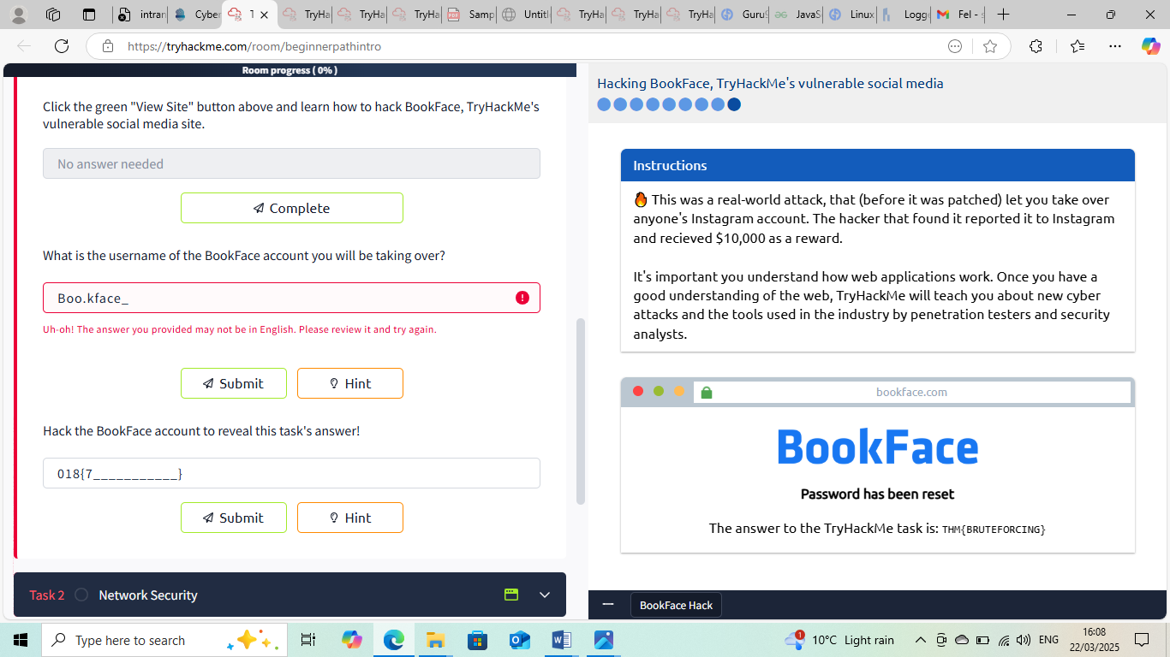
NB: With reference to the screenshot above ,some of the answer spaces provided in the TryHackMe training room does not accept inputs irrespective of the right answers .Pardon I have to take the screenshot this way.
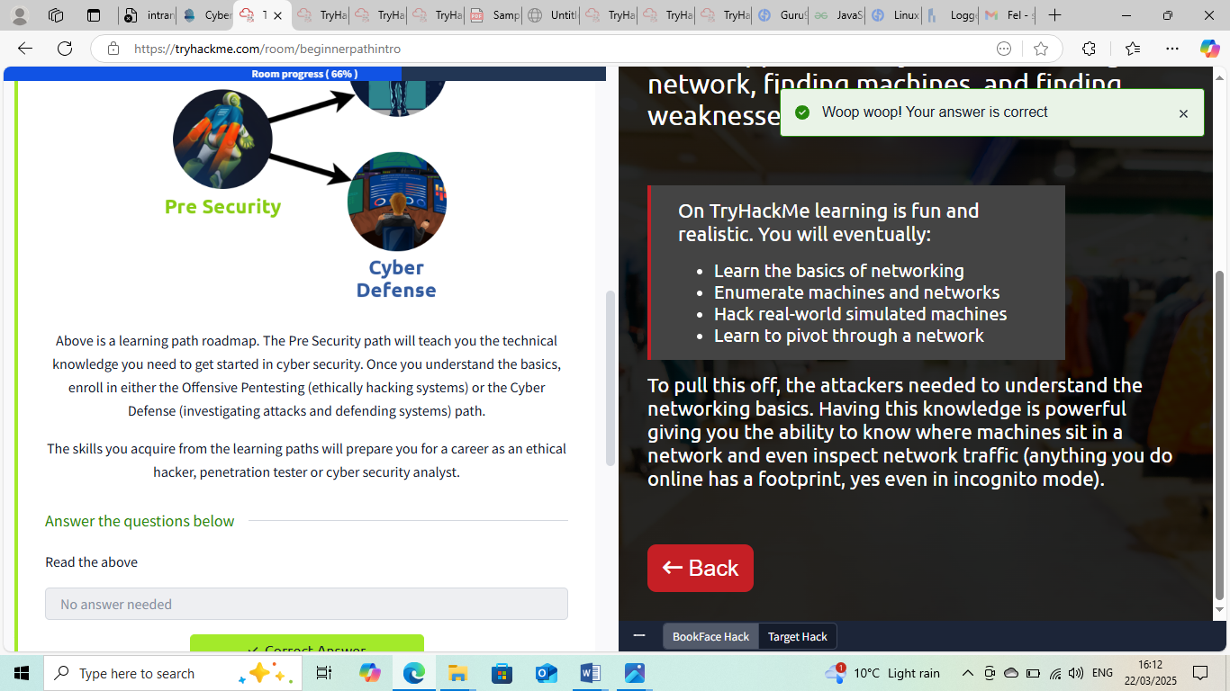

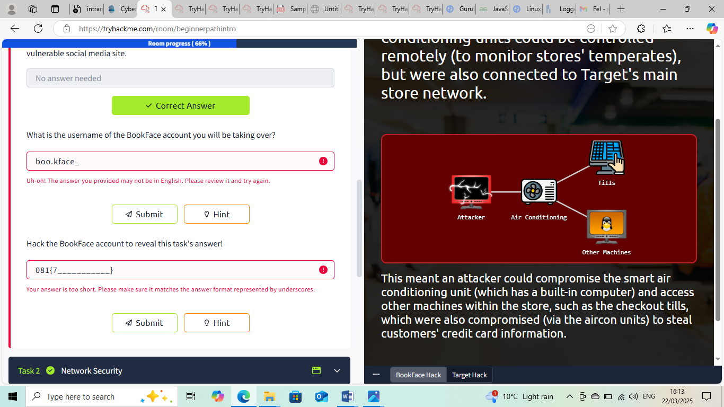
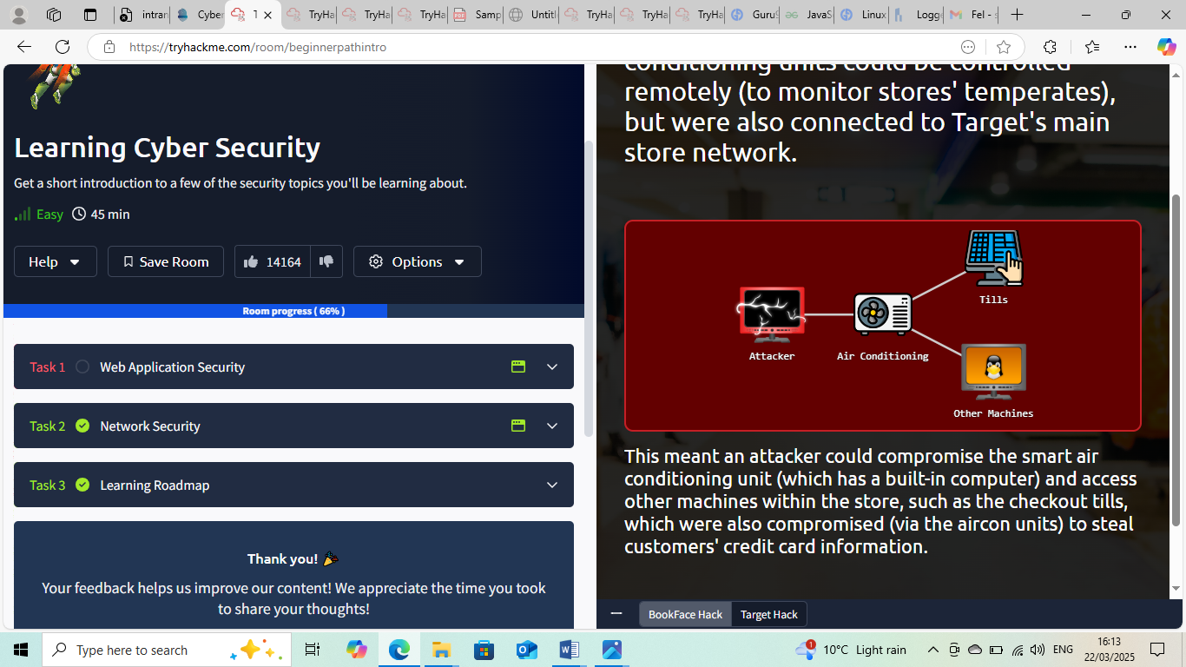
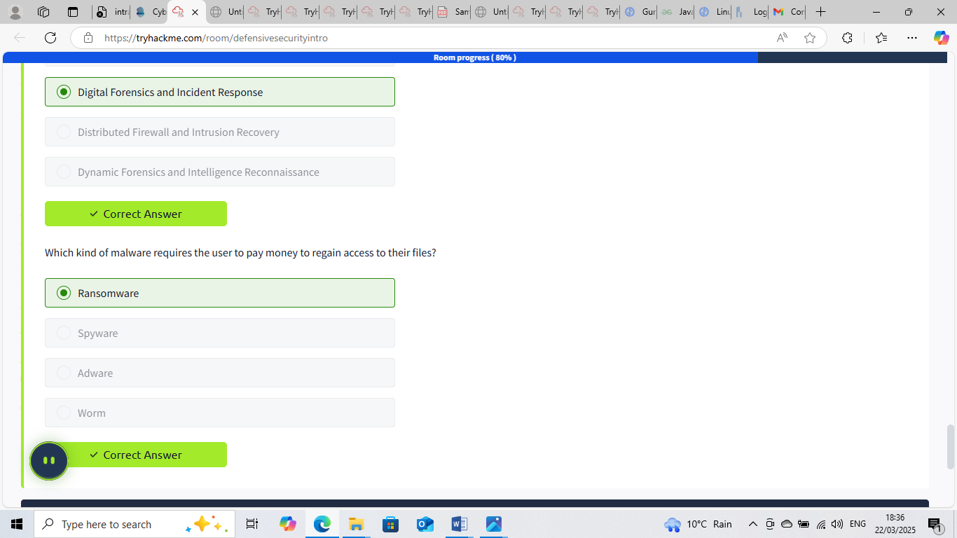
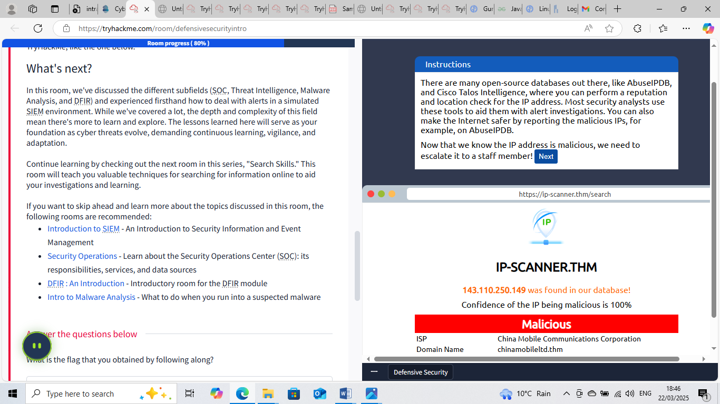
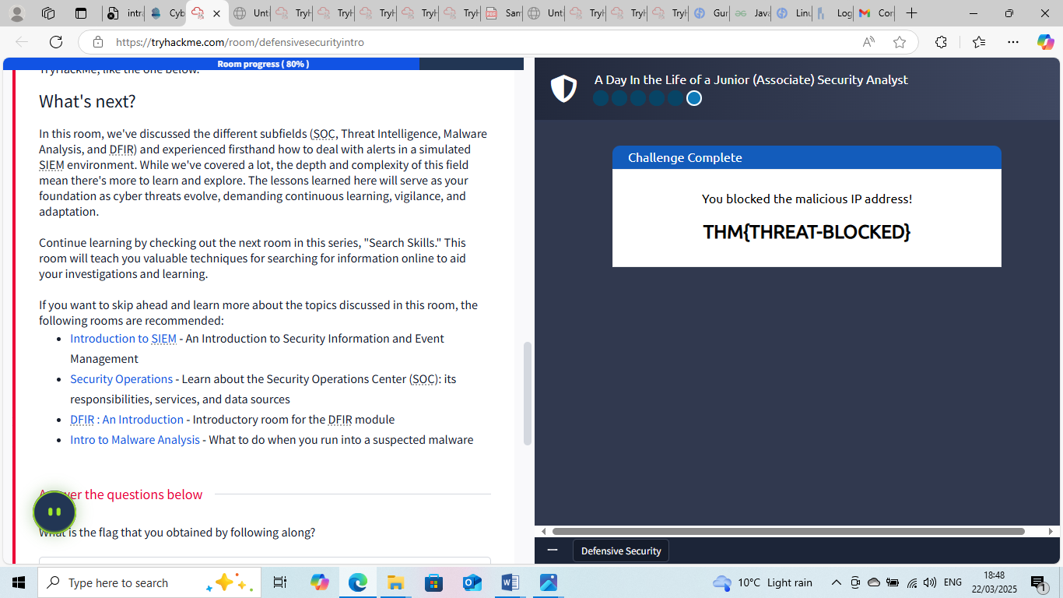

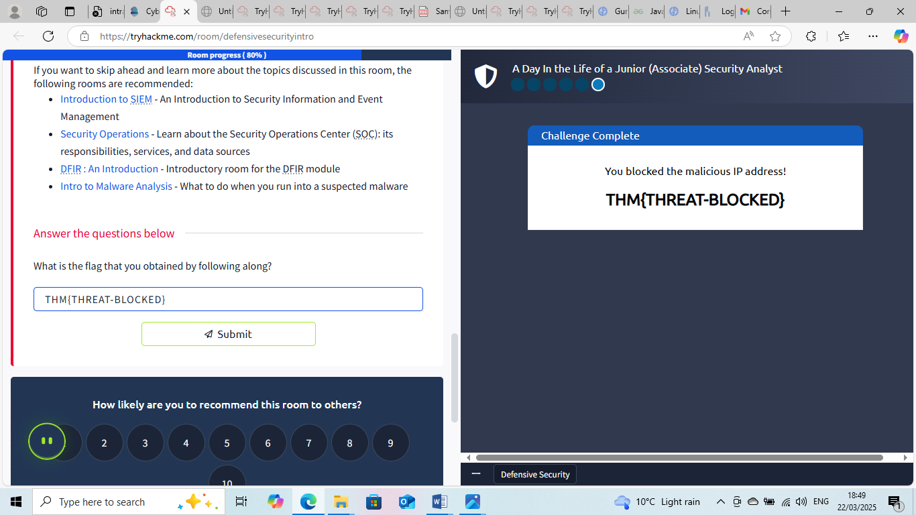


This Internship Task report was developed on [March, 23, 2025]

By:
[samfelix15@gmail.com]

